MITM Capstone Experience
Capstone Project - Week 8
Project Charter: Cybersecurity Framework - OAuth
By: DeShaun Riddick
Email: driddick@my.keller.edu
DeVry University
Course Number: MIS601
Professor: Dr. Dan
Date: 04/12/2026

Contents
Problem Statement 5
Project Objectives 6
Project Requirements 6
Possible solutions 7
Constraints 9
Project Charter 10
Executive summary 10
Project Purpose & Justification 11
Project Description & Scope Statement 12
Project Description: 12
Scope Statement: 13
In Scope: 13
Out Of Scope: 13
Project Objectives & Success Criteria 13
This project will utilize S.M.A.R.T. to keep the project on track. 13
Success Criteria: 14
Requirements 14
Functional Requirements: 14
Non-Functional Requirements: 14
Constraints, Assumptions & Risk 15
Constraints: 15
Assumptions: 15
Risks: 15
Project Deliverables 16
Summary Milestone Schedule 16
System Requirement Specification 18
Traffic Signal Simulator Access Portal (T-SAP) 18
Purpose: 18
Scope: 18
The Scope Details: 19
Definitions, Acronyms, & Abbreviations 19
Overview of the Rest of the Document 21
Overall Description 21
Product Perspective 21
Product Functions 22
User Characteristics 22
Constraints 22
Assumptions & Dependencies 22
Specific Requirements 23
External Interface Requirements 23
Hardware Interfaces 23
Software Interface 23
Communications Interface 24
Functional Requirements 24
Authentication Model 25
Performance Simulator Functionality 26
Design Constraints 27
Other Requirements Considerations 28
Artificial Intelligence 28
Cybersecurity 28
Cloud 28
Big Data & Analytics 28
Mobile Compatibility 28
Network & Database Design Specifications 29
Database Design Specifications 29
Database Schema Overview 29
Authentication Tables 29
Flowcharts 29
Cost Benefit Analysis 29
Benefits 30
Security Plan & Project Plan 30
Project Plan 31
Introduction 31
2. High-Level Workflows & Activities 32
Authentication Workflow 32
2.2 Simulation Workflow 33
2.3 Administrative Workflow 33
3. Tools & Environment 34
3.1 Infrastructure 34
3.2 Application Stack 34
3.3 Development Tools 34
4. Roles & Responsibilities 35
5. WBS Development Process 36
5.1 Define Project Scope 36
5.2 Identify Major Deliverables 36
5.3 Decompose Deliverables 37
5.4 Assign Effort & Duration 37
6. Work Breakdown Structure 37
SECURITY PLAN 41
7. Purpose (Policy Statement) 44
8. Risk Assessment 49
9. Control Activities 50
9.1 Firewall Configuration 50
9.2 Intrusion Prevention & Detection 51
Intrusion Prevention System (IPS) Controls: 51
Intrusion Detection System (IDS) Controls: 51
9.3 Access Controls 52
10. Organization of Information Security 52
11. Accountability of Assets 52
12. Communications 52
12.1 Security Communication Channels 52
12.2 User Communication Policies 52
13. Incident Response Team 52
13.1 Incident Classification 53
14. Incident Response Process 54
Phase 1: Preparation 54
Phase 2: Detection & Analysis 54
Phase 3: Containment, Eradication, & Recovery 55
Immediate Containment: 55
Eradication: 55
Recovery: 55
Phase 4: Post-Incident Activity 56
References 56

Problem Statement
Traditionally, username and password authentication systems are vulnerable to threat actors who seek to exploit security flaws to create a poor user experience. Storing user credentials in an internal application database in plaintext creates a single point of failure (SPOF). When a database is breached, the user becomes exploited because the passwords are exposed. This creates cascading effects leading to identity theft, data-theft, and loss of trust. Many users are then forced to create new usernames and passwords, thus resulting in password fatigue. Some users may even try to recycle passwords across services, unaware that weak passwords certainly have the propensity to become automated injection tools used by threat actors.
With the stolen username and password pairs (“credentials”) entered to website login forms, to fraudulently gain access to user accounts. This dramatically increases the risk of credential stuffing attacks (Mueller, 2026). Modern users expect logging into websites to be user friendly and without hassle. With one click, a user you can securely log in without memorizing new passwords. More secure user friendly, and scalable authentication method that leverages trusted third-party identity providers is essential for any modern web application.

Project Objectives
- Providing open authentication 2.0/open ID connect: this enables users to log in securely using Google.
- The eradication of internal database storage of user passwords inside the application.
- Developing one click login experience that's user friendly (sign in with Google) enabling higher usability.
- Furnishing a fully functional prototype that demonstrates the following:
  - Log in using Google.
  - secure dashboard exhibiting the user's name, e-mail, and profile picture.
  - Assured logout and end of session functionality.
  - Ensure the solution is within the framework to industry standard security best practices, (HTTPS (Hypertext Transfer Protocol Secure) is a secure version of the HTTP protocol that uses the SSL/TLS protocol to encrypt data sent between a web browser and a website and token handling, cookie security), (SSL Corp, 2025).

Project Requirements
Assessing technical feasibility includes evaluating the ability of computer hardware and software to handle workloads adequately (Kendall & Kendall, 2013).
- Functional Requirements for OAuth Authentication Flow
- The application must be homogeneous with OAuth provider: Google.
- If an end user clicks the sign in with Google, a redirection to the providers’ official login page must occur.
- Upon successful authentication of the users’ credentials, the application receives an authorization code. This code is exchanged for an access token that retrieves the users’ profile data for example: (name, e-mail, unique user ID, and profile picture).
- Session management
- Upon completion of the authentication, it's followed up by creating a secured server-side session (HTTP dash only cookie).
- Session timeout occurs after 30 minutes of inactivity.
- End users will need a logout button that will kill the session and redirect to the landing home page.
- A Secured Dashboard
- A dashboard that's only available to authenticate users should be displayed.
- Upon that display users can find their username, e-mail, and profile picture (from the identity provider).
- Notification confirming you are securely logged in via Google.
- Handling Errors
- When a user cancels login at the provider page, a message should be shown stating the following: Authentication cancelled. Please try again.
- Expired tokens are invalid and automatically should trigger reauthentication.

Possible solutions
- Custom Username/ Password System
- Developing a login system for a user database.
- SAML-Based Single Sign On (SSO). Single Sign-On (SSO) is an authentication method that allows a user to log in with a single set of credentials (like a username and password) to access multiple applications or systems within a single session. SAML (Security Assertion Markup Language) is an open standard for exchanging authentication and authorization data between parties, typically between an identity provider and a service provider (Solutions, 2025).
- OAuth 2.0 / OpenID Connect (Chosen Solution) this is within the industry as a standard OAuth 2.0 (authorization) and OpenID Connect (authentication) to delegate the login to Google. This is a viable solution because it will eliminate the need for password storage on the application. This is a one click login that is very user friendly when going to sign in with Google. It is also considered effectively secure to use short lived tokens, with cryptographic signing, under the framework of HTTPS. The speed of implementing this solution is fair and it is an industry standard.

Constraints
- Time Constraint
- The must be completed within the next 7 weeks.
- Budget Constraint
- Zero Monetary budget. All tools must be open source:
- Google developer accounts are free for testing.
- Technical Constraints
- Utilizing an identity provider, Google for integration adding more would be outside of the scope because development runs on a local host there are no options for deployment to a live server.
- Data privacy Constraints
- No personal data is to be stored on the application itself concerning the credentials. Name, e-mail, user- ID could be stored permanently. Once the session is closed the e-mail address retrieved cannot be stored. Ideally a privacy notice should appear on the login page.
- Skill Constraint
- Limited experience in developing OAuth, not using OAuth implementation.
- Regulatory Constraint
- Must comply with industry standards while all user data handling must be documented in the final report. Standards: OAuth 2.0 RFC 6749 and OpenID Connect 1.0.

Project Charter
Secure Identity Management & Traffic Signal Simulation Access System
Date: 3/15/2026
Project Title: Secure Identity Management & Traffic Signal Simulation Access System (SIMSEC)
Project Sponsor: Chief Analyst / IT Director
Project Manager: DeShaun Riddick

Executive summary

This project addresses a critical need for secure, user- friendly authentication in our Traffic Signals Website. The traditional username and password are vulnerable in our ecosystem to attacks. We currently have a Single Point of Failure (SPOF), through storing user credentials in internal application databases in plaintext format. Many of the potential SPOFs exist in the data center, frequently without the administrators' knowledge (Kirvan & Bigelow, 2021). Some risks include data breaches, credential theft, regulatory noncompliance, and loss of stakeholder trust. When technicians log into traffic signals website, we need to track who's logging in.
The proposed project’s goals are to transition from our insecure local authentication to a formidable Open Authentication 2.0 (OAuth 2.0)/OpenID Connect model leveraging secure third-party identity provider (Google). To eliminate the management of password security by shifting to Google, it will streamline the user experience to password less convenience. This establishes a secure gateway to grant access to the proprietary Traffic Signal Simulator (TSS), and this also serves as a tool for the New York State Department of Movement (NYSDOM) design department for rebuilding intersections and innovating the traffic signal system. This project will deliver a fully functional prototype that will adhere to industry standards including best practices Hypertext Transfer Protocol Secure (HTTPS) encryption and token management ensuring that the state agency can operate its simulation resource securely.

Project Purpose & Justification
The primary purpose of this project is to modernize our authentication infrastructure for in-house source tools to follow our global cybersecurity standards. Justification stems from the growing threat landscape involving brute force attacks, credential stuffing attacks, cross site script and automated injection tools use by threat actors to exploit weaknesses that come from poor password behaviors. By introducing OAuth, instead of continuing to store user credentials on the local site, our liability becomes less when we transfer responsibility to a third party that can mitigate that risk and hold sensitive data. This decision is an alignment with the agencies’ strategic direction to innovate and improve our TSS.
With the project enhancing the TSS, allowing authorized personnel to train on intersection modeling without compromise to personal data, moving forward with this project is strategic. Cross-Site scripting (XSS) is a common class of vulnerabilities in the domain of web applications. As it remains prevalent despite continued efforts by practitioners and researchers, site operators often seek to protect their assets using web application firewalls (WAFs) (Garn et al., 2021). Justification also is derived from the business needs tied to the security risk reduction, user experience improvement, modernization of the authentication stack, reduction of identity-related operational and incident response workload. Productivity should increase once OAuth is established.

Business & Business Objectives
Business Need Logic:
- Security Compliance: Current methods expose the agency to non-compliance with modern data protection expectations.
- User Experience: Users currently complain about password fatigue due to having to manage multiple logins and increasing length of credentials. This project reduces friction.
- Risk Mitigation: Prevents data-theft effecting potential data breaches and the lateral moves database is regarding user credentials from threat actors.
Business Objectives:
- Eradicate the storage of user credentials and internal databases.
- Mitigate the surface area for credential stuffing, cross site scripting, and brute force attacks. Credential stuffing remains one of the most scalable and persistent threats on the internet. While defenders have improved at catching basic abuse, attackers now operate with mature tools, shared playbooks, and infrastructure designed to evade traditional detection (Vastel, 2025).
- Adhere to 100% user session security via HTTPS and secure token handling.
- Provide a user-friendly, one click-login capability to access internal resource tools such as TSS.
- Execute a secure method auditing login attempts within the system.

Project Description & Scope Statement

Project Description:
The project entails developing a simple web-based portal that utilizes third-party Identity Providers (IdPs) for authentication. After a user is authenticated, users are granted access to TSS module dashboard. The system will record successful login events within a simple database for audit purposes distinct from credential storage.

Scope Statement:

In Scope:
- Integration of Google OAuth provider.
- Development of a landing page displaying login buttons sign in with Google.
- Creation of the secured Traffic Signal Simulator interface featuring the intersection that controls the vehicle flow.
- Implementation of a database to log in timestamps and user ID no passwords.
- Configuration of Secure Sockets Layer/Transport Layer Security SSL/TLS protocols (HTTPS).
- Log out functionality insuring set termination.

Out Of Scope:
- Creation of a social media account on behalf of the user.
- Storage of any hashed or plain text passwords from NYSDOM.
- A mobile application development.
- Real-time integration with government traffic systems outside of the simulator the logic.

Project Objectives & Success Criteria

This project will utilize S.M.A.R.T. to keep the project on track.
- Specific: Integrate OAuth 2.0 libraries for two major IdPs by the end of Q3.
- Measurable: Achieve 0 instances of credential leakage during penetration testing.
- Attainable: Utilize existing open-source libraries and cloud hosting services.
- Realistic: Aligns with current team skillsets in web development and security protocols.
- Time-bound: Development and user acceptance test completion by April 15, 2026.

Success Criteria:
- Security: No plain text passwords in the database.
- Usability: Successful login within 5 seconds per attempt.
- Functionality: TSS responds correctly to user login.
- Compliance: All data transfers are encrypted via HTTPS.
- Stability: System operates without downtime exceeding 2 hours during scheduled maintenance window.

Requirements

Functional Requirements:
- System shall allow users to select Sign in with Google on the landing page.
- System shall retrieve user profile picture, e-mail, and name from the IdPs.
- System shall display a secure dashboard containing user metadata immediately following authentication.
- System shall redirect authorize users to the TSS interface.
- The TSS simulator will visualize an intersection with dynamic cars and controllable traffic lights.
- System shall capture and store login event metadata (Timestamp, User ID, Status).
- System shall provide a visible logout button that invalidates active tokens and securely closes session.

Non-Functional Requirements:
- Data Encryption: All communication must occur over HTTPS and SSL/TLS.
- Session Management: Access tokens will be handled securely.
- Performance: Page load times should not exceed 3 seconds.
- Scalability: Architecture must support at least 100 concurrent users without degradation.

Constraints, Assumptions & Risk

Constraints:
- Budget: There's a limited funding premium cloud hosting enterprise license Application Programming Interface (API).
- Time: Project timeline stapled for academic delivery purpose and the span of eight weeks.
- Technology: The project is dedicated to the reliance of Google that API availability is outside the project team's control.

Assumptions:
- Users subscribe to a valid Internet Service Provider (ISP) to access the site.
- Users already have accounts with Google.
- The Traffic Signal Simulator logic intersection/cars on the front-end visualization does not require complex licenses.
- The firm's policy permits the use of commercial social media OAuth provider.

Risks:
- API Changes: Google reserve the right to update their OAuth requirements.
- Vendor Dependency: If IdPs are unavailable, the API cannot authenticate users
- Phishing: Threat actors could attempt to mimic the login page.
- Privacy: Users may hesitate to grant permission to third party applications.

Project Deliverables
- Connecting login page with Google to securely authenticate sessions and access controlled TSS interaction with a defined intersection vehicle behavior.
- Frontend Prototype: High functioning fully interactive web interface for the traffic signal simulator.
- Dashboard User Interface (UI): User profile viewing interface.
- Database Schema: Documentation of the login logs table without password meta data.
- Deployment Package: Deployed URL accessible for stakeholder review.
- Security Report: Confirming HTTPS enforcement & token security measures.
- User Manual: Guide on how to utilize the simulator after logging in.

Summary Milestone Schedule
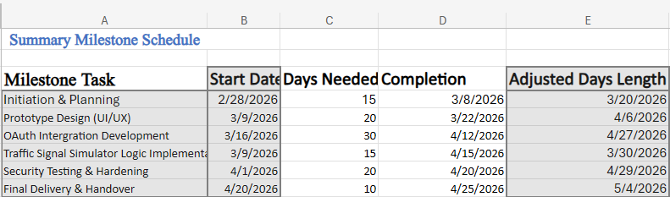
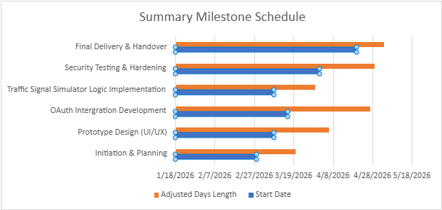

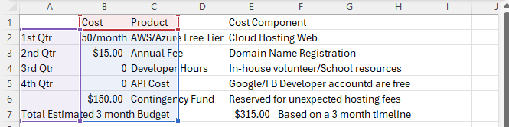
Prepared by: _______DeShaun Riddick_____Date:3/15/2026_____
Approved by:_______________________________Date:_____________

System Requirement Specification

Traffic Signal Simulator Access Portal (T-SAP)
Document version: 1.0
Date: 03/29/2026
Prepared by: DeShaun Riddick
Status: Draft
  - Introduction

Purpose:
The purpose of this System Requirements Specification (SRS) is to define the functional nonfunctional requirements for the Traffic Signal Simulator Access Portal (T-SAP). This document serves as a physical blueprint for the development team to build the system securely. It details the authentication protocols (OAuth), dashboard functionalities, any later mechanics, and security protocols required to replace the legacy plain text password database system.

Scope:
T-SAP is a web-based application designed to provide secure access to a TSS environment. This system insecure username/ password storage within a third-party IdP authentication (Google).

The Scope Details:
- Implementation of OAuth 2.0 authentication flow.
- Creation of a user dashboard displaying profile information.
- Development of the TSS interface with the intersection visualized.
- Database logging of logging events excludes plaintext credentials.
The scope this includes native mobile application development, real world traffic signal integration, and historical data analysis beyond current session logs.

Definitions, Acronyms, & Abbreviations
- API: Application Programming Interface.
- Attainable: Utilize existing open-source libraries and cloud hosting services.
- Compliance: All data transfers are encrypted via HTTPS.
- Dashboard User Interface (UI): User profile viewing interface.
- Data Encryption: All communication must occur over HTTPS and SSL/TLS.
- Database Schema: Documentation of the login logs table without password meta data.
- Deployment Package: A live accessible URL of the deployed system for stakeholders to review and evaluate.
- Frontend Prototype: A fully interactive web interface that simulates traffic signal operations for user interaction and testing.
- Functionality: TSS responds correctly to user login.
- HTML CSS: Hypertext markup language standard language used to structure content on web page. Cascading style sheet is used to control the visual presentation of that content
- HTTPS: Hypertext Transfer Protocol Secure is a secure version of the HTTP protocol that uses the SSL/TLS protocol to encrypt data sent between a web browser and a website and token handling, cookie security.
- IdP: Identity provider (e.g., Google)
- IEEE: (830-1998 - IEEE Recommended Practice for Software Requirements Specifications, 1998)

- ISP: Internet Service Provider
- Measurable: Clearly defined security objectives that can be quantitatively validated through testing. Achieve 0 instances of credential leakage during penetration testing.
- NYSDOM: New York State Department of Movement
- OAuth 2.0: Open Authorization 2.0 (Industry-standard protocol for access delegation).
- Performance: A critical web usability metric referring to how quickly a web page loads and becomes interactive. Page load times should not exceed 3 seconds.
- Phishing: What type of cyberattack in which an attacker impersonates a legitimate entity to deceive users into revealing sensitive information including credentials, credit card numbers, or personal data.
- Privacy: Users may hesitate to grant permission to third party applications.
- Realistic: Aligns with current team skillsets in web development and security protocols.
- Scalability: Architecture must support at least 100 concurrent users without degradation.
- Security Report: Confirming HTTPS enforcement & token security measures.
- Security: No plain text passwords in the database.
- Session Management: Access tokens will be handled securely.
- Specific: Integrate OAuth 2.0 libraries for two major IdPs by the end of Q3.
- SPOF: Single point of failure.
- SRS: System Requirements Specification
- SSL/TLS: Secure Sockets Layer / Transport Layer Security (encryption protocols).
- Stability: System operates without downtime exceeding 2 hours during scheduled maintenance window.
- Time-bound: Development and user acceptance test completion by April 15, 2026.
- Token: A string of characters used for secure identification at this session.
- T-SAP: Traffic Signal Simulator Access Portal
- UI: User Interface
- Usability: Successful login within 5 seconds per attempt.
- User Manual: Guide on how to utilize the simulator after logging in.
- Vendor Dependency: If IdPs are unavailable, the API cannot authenticate users

Overview of the Rest of the Document
The remaining sections are providing a brief overview of the product perspective with detailed external and internal interface requirements. Ultimately addressing specific considerations regarding cyber security and other technologies such as AI.

Overall Description

Product Perspective
The T-SAP is a standalone web application deployed via cloud infrastructure from Google. This application operates independently of the firm's legacy application. There is a dependency on Google for authentication validation. The simulator module is the primary business functionality that's protected by the new authentication layer.

Product Functions
- Authentication: Manage user identity via social login provider.
- Session management: Maintain active states for authorized users, terminating them upon logout.
- Simulation Control: Allow users to visualize and modify traffic light patterns at a virtual intersection.
- Audit Logging: Record metadata associated with login attempts that are successful without storing them in plaintext on the application.

User Characteristics
- Trainees/Analyst: Personnel requiring access to the simulator for traffic design and urban planning. They are expected to have basic Computer literacy and valid Google accounts.
- System Administrators: IT staff responsible for monitoring the health of the servers and managing user access list with a limited role and initial phase.

Constraints
- Technology: Must use modern web standards HTML5 CSS3, JavaScript.
- Compliance: Must adhere to strict security policies that prohibit plain text password storage and application.
- Availability: Third party authentication Google requires stable Internet connection. Offline usage is not supported.

Assumptions & Dependencies
- Assumptions: Users trust the organization enough to authorize Google Permissions.
- Dependency: The system relies on the continued uptime of Google OAuth endpoints.
- Assumption: All browsers accessing the site support modern TLS 1.2 plus encryption.

Specific Requirements

External Interface Requirements
User interface must be clean, responsive, and accessible.
- Requirement-UI-1: The login screen must display two distinct buttons sign in with Google.
- Requirement-UI-2: Once logged in the dashboard must show the user's name, profile picture and verified e-mail address.
- Requirement-UI-3: The traffic light simulator must feature a graphical representation of an intersection showing lane markings stop lines and vehicle icons.
- Requirement-UI-4: controls start, stop, change signal must be visible and clickable on both the desktop and the laptop.

Hardware Interfaces
- Requirement-HW-1: The virtual private server hosting the application must possess sufficient CPU and ram could manage traffic simulations for at least 50 concurrent users.
- Requirement-HW-2: Flying devices such as laptops tablets phones require no specialized hardware beyond standard browser capabilities.

Software Interface
- Requirement-SW-1: System utilizes open-source libraries or OAuth 2.0 integration.
- Requirement-SW-2: The database must be compatible with standard SQL queries or logging purposes.
- Requirement-SW-3: The front-end framework must allow for asynchronous state management to little token expiration accordingly.

Communications Interface
- Requirement-COM-1: All communication between client and server must occur over HTTPS using SSL/ TLS protocols.
- Requirement-COM-2: The system must enforce Cross-Origin Resource Sharing to prevent unauthorized domain access to APIs.
- Requirement-COM-3: Sessions must time out automatically after 15 minutes of inactivity.

Functional Requirements
Functional coverage and validation metrics are how T-SAP in shores comprehensive coverage as the system undergoes multi layered validation processes that will guarantee reliability. Authentication workflows are evaluated via automated scripts simulating OAuth handshakes, verifying that no plain text credentials will traverse the internal network or any API calls. T-SAP has a multitude of security protocols using a vulnerability scanner to enforce https://encryption and validate the token expiration logic at its server level. The network connectivity is monitored throughout packet analysis that will guarantee data integrity while transmitting between the client browser and the central server. Each Functional requirement is paired with specific quantitative acceptance criteria to verify success. To give an example, successful login transactions must be averaged below 2.0 seconds from initiation to the dashboard load. Cloud service availability must reach a 99% uptime during scheduled testing hours. These metrics are measurable and attainable in a way that they align with the organizational security posture.

Authentication Model
Artificial intelligence and the traffic signal access portal are integrated with modular components capable of supporting machine learning algorithms within the core simulation logic. The system process is establishing secure data lake where historical traffic patterns are stored for training and predictive models, ensuring no raw personal identifiable information is exposed during analysis. Security protocols will encrypt all data at rest and use role based access controls to limit who can modify the underlying algorithms the functional requirements are verified through precision testing, measuring the alignment between the algorithmic predictions and actual vehicle behavior simulation the success metrics include an accuracy threshold of 85% for car movement predictions and an API response time of under 200ms for recommendation request. These standards ensure that the artificial intelligence lair enhances usability without introducing vulnerabilities or performance degradation to the system.

- Requirement-FUN-1: Users click a social login button; the system shall redirect them to the respective IdP consent screen.
- Requirement-FUN-2: With the users consent, the system shall receive a secure JSON Web Token (JWT) and verify the Signature.
- Requirement-FUN-3: The system will create a session record in the database containing the user ID, log in time, IP address, and status showing success or failure.
- Requirement-FUN-4: The system shall never store a password hash or plain text passwords in the internal application database ever.

Performance Simulator Functionality
The performance of T-SAP is of a responsive and efficient user experience. Performance requirements are steadfastly validated throughout the entire platform stack. Open system processes are measured through load testing and simulation that replicate high volume authentication events in our concurrent simulators sessions that are tracking the CPU utilization and memory footprints that prevent bottlenecks and the need for more resources and do some budget creep. Network efficiency is verified by analyzing packet transmission speeds yielding to secure HTTPS communication with minimal latency during data exchanges between the clients and servers. Security processes, such as cryptographic token verification are benchmarked to confirm they do not impede transaction speeds or cause timeouts. The KPI's include page load times remaining under 2 seconds, and maintaining 30 frames per second during traffic visualization, resulting in a 95% response rate for API calls. These metrics are continuously tracked using application performance monitoring tools that are guaranteed to maintain stability under stress.

- Requirement-SIM-1: The simulation engine the cars moving through the intersection based on green light intervals.
- Requirement-SIM-2: An administrator user shall be able to manually change the signal state from red, green, and yellow.
- Requirement-SIM-3: Cars shall come to a complete halt at red lights and proceed during green lights according to pre-defined logic rules.

Design Constraints
With architecture design, there are constraints that T-SAP are meticulously applying across the entire system of the infrastructure. Guaranteeing operational processes, and security protocols to support core functional capabilities, the model view control framework enforces a modular system design which can take the business logic and segregated from presentation layers. The functionality of the module, such as the traffic simulator, will remain stable during updates. Another design constraint is rapid iteration login workflows. The integrity of the network will still be operational despite the streamlined development process allowing for this action to take place. Network topology with CORS administered through encrypted data channels, ensure design limitations do not compromise user session safety. The network is containerization on the virtual private server with various deployment methods that can hedge against environmental drift between testing and production that could break functional API. Validation through tracking technical debt ratio to ensure code quality does remain with monitoring the failure rates to inform process adherence.

- Design-1: The application architecture will follow the model view controller pattern for code modularity.
- Design-2: The code must be containerized to facilitate deployment across different environments.
- Design-3: The database schema must normalize login logs to 3rd normal form.

Other Requirements Considerations

Artificial Intelligence
- Requirements Considerations-AI-1: The traffic signal timing module can expose an API endpoint capable of receiving input values this will support future machine learning models for dynamic signal optimization.
- Requirements Considerations-AI-2: The system will also capture high frequency data points to monitor behavior.

Cybersecurity
- Requirements-CYB-1: Passwords will not exist in the system total reliance upon IDP is necessary.
- Requirements-CYB-2: All cookies set by the application must have HTTP only, secure, and same site equals strict flags enabled to mitigate XSS & MITM attacks here.
- Requirements-CYB-3: Regular automated vulnerability scanning should be included on the CI/ CD pipeline before deployment.

Cloud
- Requirements-CLD-1: The application must be hosted on a reputable cloud provider.
- Requirements-CLD-2: Backups of the login log database shall occur with a retention policy of 30 days.

Big Data & Analytics
- Requirements-BIG-1: Login events should be structured in Jason format.

Mobile Compatibility
- Requirements-MOB-1: The Interface must be fully responsive.
- Requirements-MOB-2: Touch Gestures should be supported but more than likely won’t be.
- Requirements-MOB-3:The system shall not require the installation of additional mobile applications; access is via web browser.
Sign-off
Role: __________Name _____________Signature _____________Date:3/29/2026_
Chief Analyst:___________________________________________Date:3/29/2026_
Project Manager: _DeShaun Riddick____ DeShaun Riddick ____Date:3/29/2026_
Technical Lead:__________________________________________Date:03/29/2026_

Network & Database Design Specifications

Database Design Specifications

Database Schema Overview
The database for the T-SAP at Trafficsignalsim.com is organized into several core tables. These tables are divided into two logical categories: authentication tables and application tables. Together, these tables provide support for the life cycle of a user interaction with the system from point A – Z, from signing in with Google to creating and running traffic signal simulations, to logging every meaningful event along the way. There's a schema that was implemented with security in mind heavily, scalability, and data integrity at the forefront of concerns. Ensuring Google OAuth 2.0 authentication layer and the simulation functionality remained cleanly separated properly linked through well-defined foreign key relationships.

Authentication Tables
The users table serves as the central identity table for the entire application. Once a user is signed in with their Google account for the first time, a new record is created in this table using the data returned from Google's authorization server. The most critical field in this table is google_sub, this stores the unique subject identifier that Google assigns to every single account. The unique the property about this value is that it never changes, even when the user updates their e-mail address or display name, this value will never change which makes it the most reliable way to link a returning user to their existing account across a host of login sessions. This table also includes a role field, which supports role-based access control by distinguishing between the regular users and administrators. Administrators may have elevated privileges such as the ability to manage other users, access platform analytics, view system wide simulation logs while users are limited to managing their own simulation data.
The OAuth_tokens table stores access tokens and ID token that Google returns after user has successfully completed the O auth 2.0 authorization code flow. Authentication only answers one question: who is this? Once the API server has a verified identity a username and zero or more group memberships, it passes the request to the authorization layer. By default, that is RBAC, which checks the identity against Role and ClusterRole bindings to determine what the request is allowed to do (Erhabor, 2026). Each row in this table is linked back to the users table through a foreign key on user_id, establishing A1 to many relationships. What this means is that one user can have multiple token records. Why this is important for users is in the authentication of that user from different browsers or devices.
Every authentication event generates A distinct set of tokens. Now the access token is short lived and is used to authorize API calls to Google services on behalf of the user while the refresh token is a much longer-lived token that allows the application to obtain new access tokens without requiring a user to sign in again. With the expires_at field tracks when the access token is set to expire and end the session that is what's going to enable the application to proactively refresh it before it becomes invalid while ensuring seamless user experience.
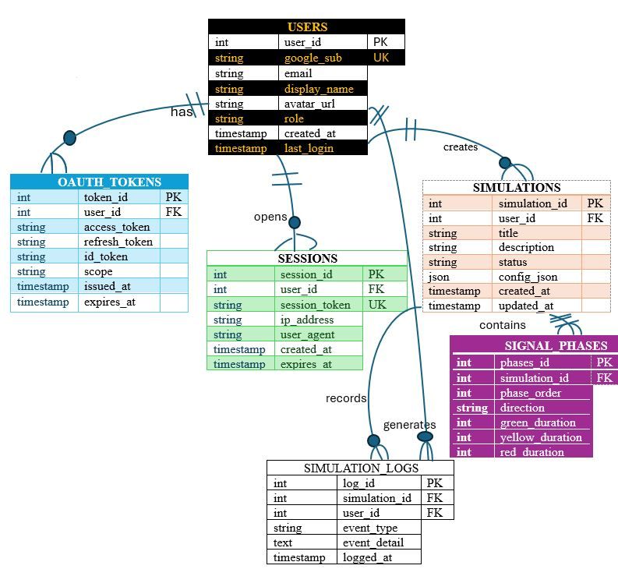

Flowcharts The Hostinger server performs the build out of the request, exchanging the code, that creates the session. Googles OAuth infrastructure then text that request from the auth server, the consent screen, token endpoint and Kali Linux security test that token to make sure that it should be running against each stage of the flow the denial error path happens when a user is rejected at the consent screen. When a user gets to the traffic signals im.com the domain name search resolution looks up the website address via DNS and that resolves to Hostinger's server IP address, and that's where the site is hosted.
The TCP handshake and TLS negotiation where the browser establishes a secure connection with hosting or server using the protocol HTTPS. The SSL certificate hostinger provides for the domain allows the TLS 1.2/ 1.3. Once the http requests are sent the browser sends a get request to hostinger web server. Once the server processes the request the application in HTML static page or a PHP script or node for traffic signals im.com begins to load the traffic simulation interface because this session is now allowed to begin through an active session cookie.
If the user is recognized as logged in and served their personal dashboard the session will begin. On the contrary the user will see the public guest view of the site including the sign in with the Google button. Once the pages are rendered in the browser, the traffic signal simulation images will appear. If the user is not logged in and clicks sign in with Google the OAuth 2.0 flow kicks off. That's going to be exactly what this flowchart displays from that point forward as shown below.

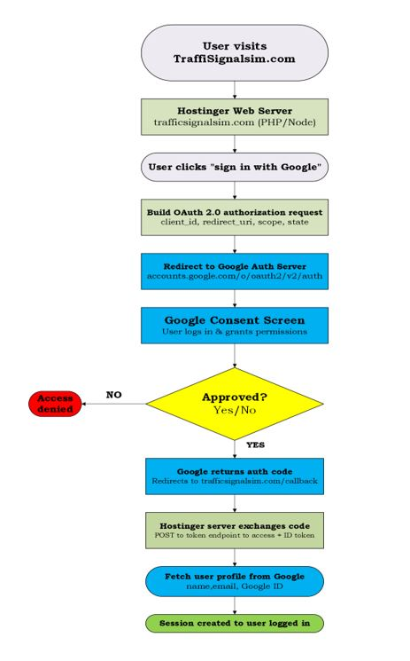
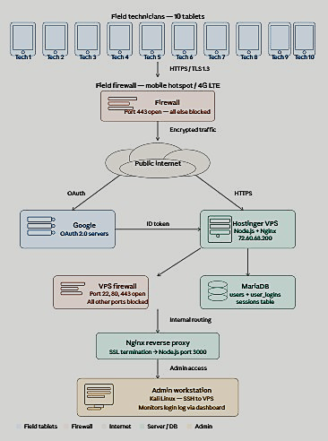

Cost Benefit Analysis
Role | Responsibilities | Logged Hours | Approved Hourly Rate | Not Approved | Grand Total Cost
Full Stack Developer | Node.js, Express, server.js, routes, session management | 20.0 hrs. | $125/hr. |  | $2,500.
DevOps Engineer | VPS setup, Nginx, PM2, SSL, DNS configuration | 10.5 hrs. | $140/hr. | 5hrs. | $770.
Frontend Developer | HTML pages, CSS styling, simulator UI | 10.5 hrs. | $95/hr. | 5hrs. | $522.5
Security Engineer | Google OAuth 2.0, OpenID Connect, session security | 20.0 hrs. | $150/hr. |  | $3,000.
Database Administrator | MariaDB setup, schema design, user tables | 48.0 hrs. | $120/hr. |  | $5,760.
QA Engineer | Testing all features, bug fixes, browser testing | 3.0 hrs. | $85/hr. |  | $255.
Total Hours |  |  | 101 hrs.
Lost Hours |  |  | 10
Final Cost |  |  | $12,807.5

Project Management & Documentation
ITEM | COST
Project Manager (10% of Dev Cost) | $366.
Technical Documentation | $200.
Network Design Specifications | $150.
Database Design Specification | $150.
Total PM & Docs | $866.

Benefits
Secure authentication from Google OAuth 2.0 eliminates the need to store passwords, reducing security risks significantly. User data collection is something that must be handled with care. Every login is recorded with e-mail, IP address, and timestamp, that full audit trail. With access controls, the Brooklyn traffic simulator is protected behind authentication. This means that only verified users can access this simulator. Scalability is recognized through using node.JS and MariaDB on a virtual private server that can scale to handle hundreds of concurrent users. The cost efficiency is through using open-source tools like node.JS, Nginx, MariaDB, and LetsEncrypt. This eliminates the licensing cost. Finally, the profit national infrastructure with full https://encryption, session management, and database backed sessions provide enterprise grade security. This project demonstrates real world implementation of OAuth 2.0, database design, network configuration, and Linux server administration.

Security Plan & Project Plan

T-SAP
Traffic Signal Access Portal
Milestone 5: Security Plan & Project Plan

Prepared by: DeShaun Riddick
Course: Network & Database Design Capstone
Date: April 2026
Website: https://trafficsignalsim.com

Project Plan

Introduction
The Traffic Signal Access Portal (T-SAP) is a full-stack web application developed to replace an insecure, plaintext password authentication system with a modern, OAuth 2.0-based identity management solution. This project was initiated in response to a critical Single Point of Failure (SPOF) identified in the existing traffic signal simulation platform used by the New York State Department of Movement.
T-SAP is deployed on a Hostinger KVM virtual private server (VPS) running Kali Linux, accessible at https://trafficsignalsim.com the system leverages Google OAuth 2.0 and OpenID Connect to authenticate users without storing credentials locally. Upon successful authentication, users gain access to the Brooklyn Traffic Intersection Simulator, a canvas- based real time traffic management simulation tool.
This project plan documents the complete life cycle of T-SAP development effort, including workflows, tools, team roles, and the Work Breakdown Structure (WBS). It serves as the authoritative planning reference for all projects stakeholders.

High-Level Workflows & Activities

Authentication Workflow
The T-SAP authentication workflow follows the OAuth 2.0 authorization code flow with OpenID connect identity verification:
- User navigates to https://trafficsignalsim.com and is redirected to the login page
- User clicks ‘Sign in with Google’ which initiates the OAuth 2.0 Authorization request
- Google authenticates the user and returns an authorization code to the callback URL
- T-SAP exchanges the authorization code for an access token and ID token
- The ID token is decoded to extract user profile data such as E-Mail, name, Google ID
- User record is created or updated in the MariaDB user’s table
- A secure server-side session is established and stored in the MariaDB sessions table
- User is redirected to the T-SAP dashboard

2.2 Simulation Workflow
Once authenticated, users access the Brooklyn Traffic Intersection Simulator through the following workflow:
- User navigates to the Dashboard and clicks ‘Launch Brooklyn Traffic Simulator’
- Server validates the active session via requireLogin middleware
T-SAP ___Traffic Signal Access Portal Milestone 5: Project Plan & Security Plan
- The simulator HTML is served from /var/www.forwardslashhtmlforwardslashbrooklynhyphentraffic.html
- The canvas- based simulation renders in real time with vehicle spawning, signal phase cycling, and traffic management
- Users can interact with simulation controls pause, phase selection, music player

2.3 Administrative Workflow
The System Administrator monitors platform activity through the following workflow:
- Admin logs in with authorized Google account
- Admin navigates to the Dashboard to view real time login statistics
- Admin reviews user logins logs including e-mail, IP address, and timestamp
- Admin manages the MariaDB database directly via SSH when necessary
- Admin monitors server health using PM2 processor manager

3. Tools & Environment

3.1 Infrastructure
Component | Specification
VPS Provider | Hostinger KVM
IP Address | 72.60.68.200
Operating System | Kali Linux (Debian-based)
Domain | trafficsignalsim.com
SSL Certificate | LetsEncrypt (Free, Auto-Renewing
Process Manager | PM2 v5
Web Sever | Nginx (Revers Proxy)

Application Stack

Technology | Purpose
Node.JS v22.22.1 | Server-side JavaScript runtime
Express.JS | Web application framework
Passport.JS | Authentication middleware
Passport-Google-oauth20 | Google OAuth 2.0 strategy
Express-session | Session management
Express-mysql-session | Database-backed session store
mysql2 | MariaDB database driver
Dotenv | Environment variable management
MariaDB 11.8 | Relational database

T-SAP ___Traffic Signal Access Portal Milestone 5: Project Plan & Security Plan

3.3 Development Tools
- Kali Linux Terminal--SSH access and server management
- FileZilla SFTP-- secure file transfer to VPS
- Google Cloud Console--OAuth 2.0 application registration and management
- Google Chrome developer tools--testing, debugging, and mobile responsive design
- PM2-- node.js process management and log monitoring
- Git---Version control and change tracking
- Visual Studio Code -- Code editing and development

Roles & Responsibilities

Role | Assigned To | Responsibilities
Project Manager | DeShaun Riddick | Overall project planning, timeline management, stakeholder communication, WBS development
Full Stack Developer | DeShaun Riddick | Node.js server development, Express routing, OAuth integration, HTML/ CSS frontend
DevOps Engineer | DeShaun Riddick | VPS setup, Nginx configuration, SSL/ TLS, DNS, PM 2 process management, firewall rules
Database Administrator | DeShaun Sequence2 Riddick | MariaDB schema design, user table management, session store configuration
Security Engineer | DeShaun Riddick | OAuth 2.0 implementation, CSP headers, session security, firewall policy
QA Engineering Team | Keoke, Tiffany, Victoria, Angel, | Browser testing, mobile responsiveness testing, authentication flow validation
System Administrator | DeShaun Riddick | Ongoing server monitoring, log review, database maintenance, user management

T-SAP ___Traffic Signal Access Portal Milestone 5: Project Plan & Security Plan

WBS Development Process
The work breakdown structure (WBS) for T-SAP was developed using a top-down decomposition approach, starting from the highest-level project objective and progressively breaking it down into manageable work packages the process followed these steps:

5.1 Define Project Scope
The project scope was established through the system requirements specification (SRS), which identified the need to replace the legacy plaintext password authentication system with a secure OAuth 2.0 solution while maintaining access to the Brooklyn Traffic Intersection Simulator.

Identify Major Deliverables
The major project deliverables were identified as:
- Infrastructure Setup- VPS provisioning, DNS configuration, SSL/TLS deployment
- Authentication System-Google OAuth 2.0 integration, session management
- Database Design schema creation, user management, session storage
- Web Application-node. JS server, express routes, HTML/CSS pages
- Traffic Simulator-Brooklyn Intersection Simulation deployment
- Security implementation- Firewall rules, CSP headers, HTTPS enforcement
- Documentation---SRS, Network Design, Database Design, Project Plan, Security Plan

5.3 Decompose Deliverables
Each major deliverable was broken down into specific task and sub task. For example, the Authentication System deliverable was decomposed into: Google Cloud Console project setup, OAuth consent screen configuration, client ID and secret generation, passport.js strategy implementation, callback URL configuration, session persistence setup, and user database integration.

5.4 Assign Effort & Duration
Each work package was assigned an estimated effort in hours and a duration in days based on technical complexity and dependencies. The total project effort was estimated at 27 hours across a 2-day development period.

T-SAP ___Traffic Signal Access Portal Milestone 5: Project Plan & Security Plan

Work Breakdown Structure
WBS ID | Task / Work package | Start Week | Duration Weeks | Effort Hours
1.1 | Project Charter | 1 | 7 | 27
1.1.1 | Requirements Gathering (SRS) | 1 | 3 | 8
1.1.2 | Risk Assessment | 2 | 1 | 8
1.1.3 | WBS Development | 2 | 7 | 8
1.2 | HostingerVPS Provisioning | 2 | 5 | 40
1.2.1 | DNS Configuration | 2 | 3 | 12
1.2.2 | NGinx + SSL/TLS SetupFirewall Rules Configuration | 3 | 4 | 2
1.2.3 | Firewall Rules Configuration | 3 | 3 | 4
1.2.4 | PM2 Process Manager Setup | 3 | 4 | 2
1.3 | MariaDB Installation | 3 | 2 | 1
1.3.1 | Schema Design (user/Logins) | 3 | 6 | 3
1.3.2 | Session Store Configuration | 3 | 2 | 8
1.4 | Google Cloud Console Setup | 3 | 7 | 10
1.4.1 | OAuth COnsent Screen Configuration | 4 | 5 | 45
1.4.2 | Passport.js Strategy Impl. | 4 | 1 | 12
1.4.3 | Session Middleware + Cookies | 4 | 1 | 10
1.4.4 | requireLogin Middleware | 4 | 3 | 5
1.4.5 | Login Logging to MariaDB | 4 | 1 | 4
1.4.6 | Google OAuth Verification | 5 | 5 | 15
1.5 | Node.js/ Express Server | 4 | 2 | 2
1.5.1 | Homepage Development | 5 | 1 | 1
1.5.2 | Dashboard Page | 5 | 7 | 1
1.5.3 | Contact Form | 5 | 1 | 1
1.5.4 | Privacy /Terms Pages | 5 | 2 | 4
1.5.5 | Moble Responsive CSS | 6 | 1 | 10
1.5.6 | Brooklyn Traffic Simulator | 5 | 2 | 45
1.6 | MP3 Upload via FileZilla | 6 | 6 | 2
1.6.1 | Player UI Controls | 6 | 6 | 4
1.6.2 | Auto-Advance Feature | 6 | 6 | 6
1.7 | CSP Header Configuration | 5 | 7 | 1
1.7.1 | HTTPS Enforcement | 5 | 6 | 1
1.7.2 | Secure Cookie Configuration | 5 | 3 | 1
1.7.3 | TLS 1.3 Enforcement | 6 | 5 | 1
1.7.4 | Vulnerability Assessment | 7 | 7 | 1
1.8 | Browser Compatibility Test | 7 | 1 | 2
1.8.1 | Mobile Responsive Testing | 7 | 1 | 2
1.8.2 | OAuth Flow Validation | 7 | 1 | 2
1.8.3 | Performance Testing | 7 | 1 | 2
1.9 | Networking Design Specs | 6 | 2 | 1
1.9.1 | Database Design Specs | 6 | 3 | 1
1.9.2 | Project Plan (Milestone #5) | 7 | 2 | 1
1.9.3 | Security Plan | 7 | 3 | 8
1.9.4 | WBS Tool | 7 | 4 | 15
1.9.5 | Gantt Chart ( Milestone 6) | 8 | 8 | 10
2.1.1 | Final Deployment to VPS | 8 | 4 | 5
2.1.2 | User Acceptance Testing | 8 | 6 | 3
2.1.3 | Stakeholder Demo | 8 | 1 | 1
2.1.4 | Project Closeout | 8 | 8 | 20

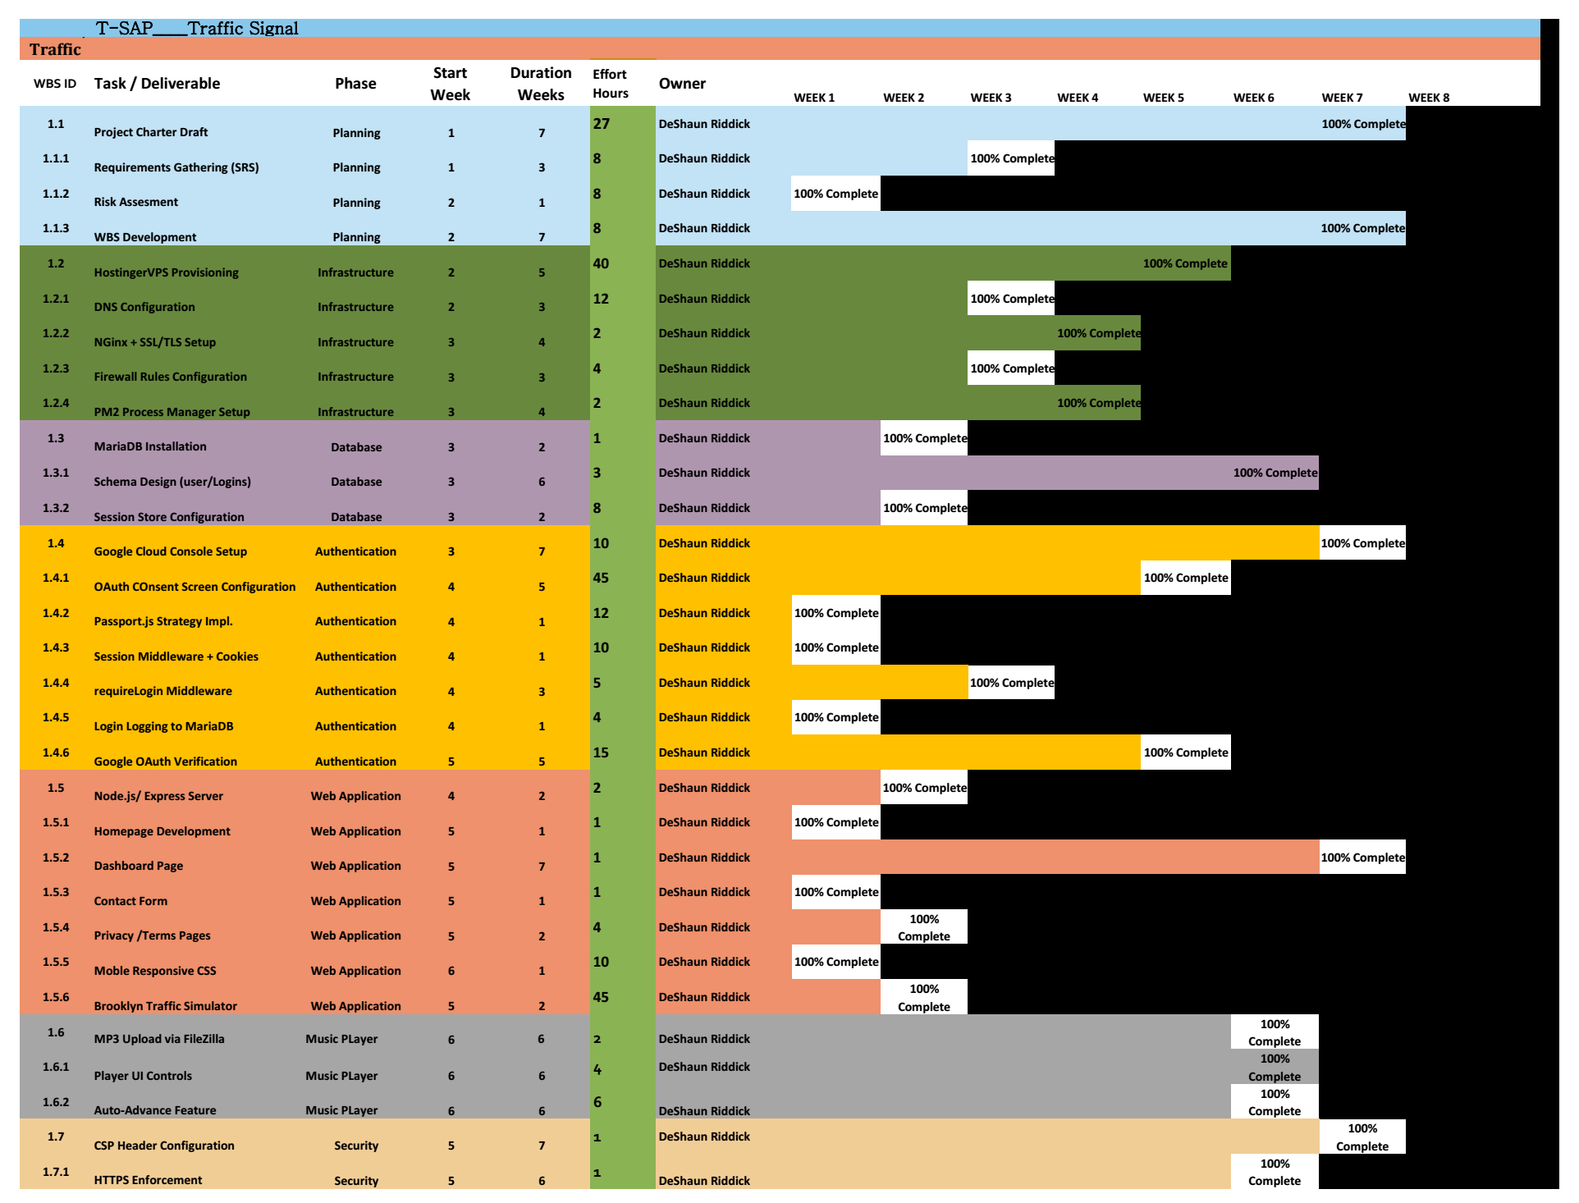
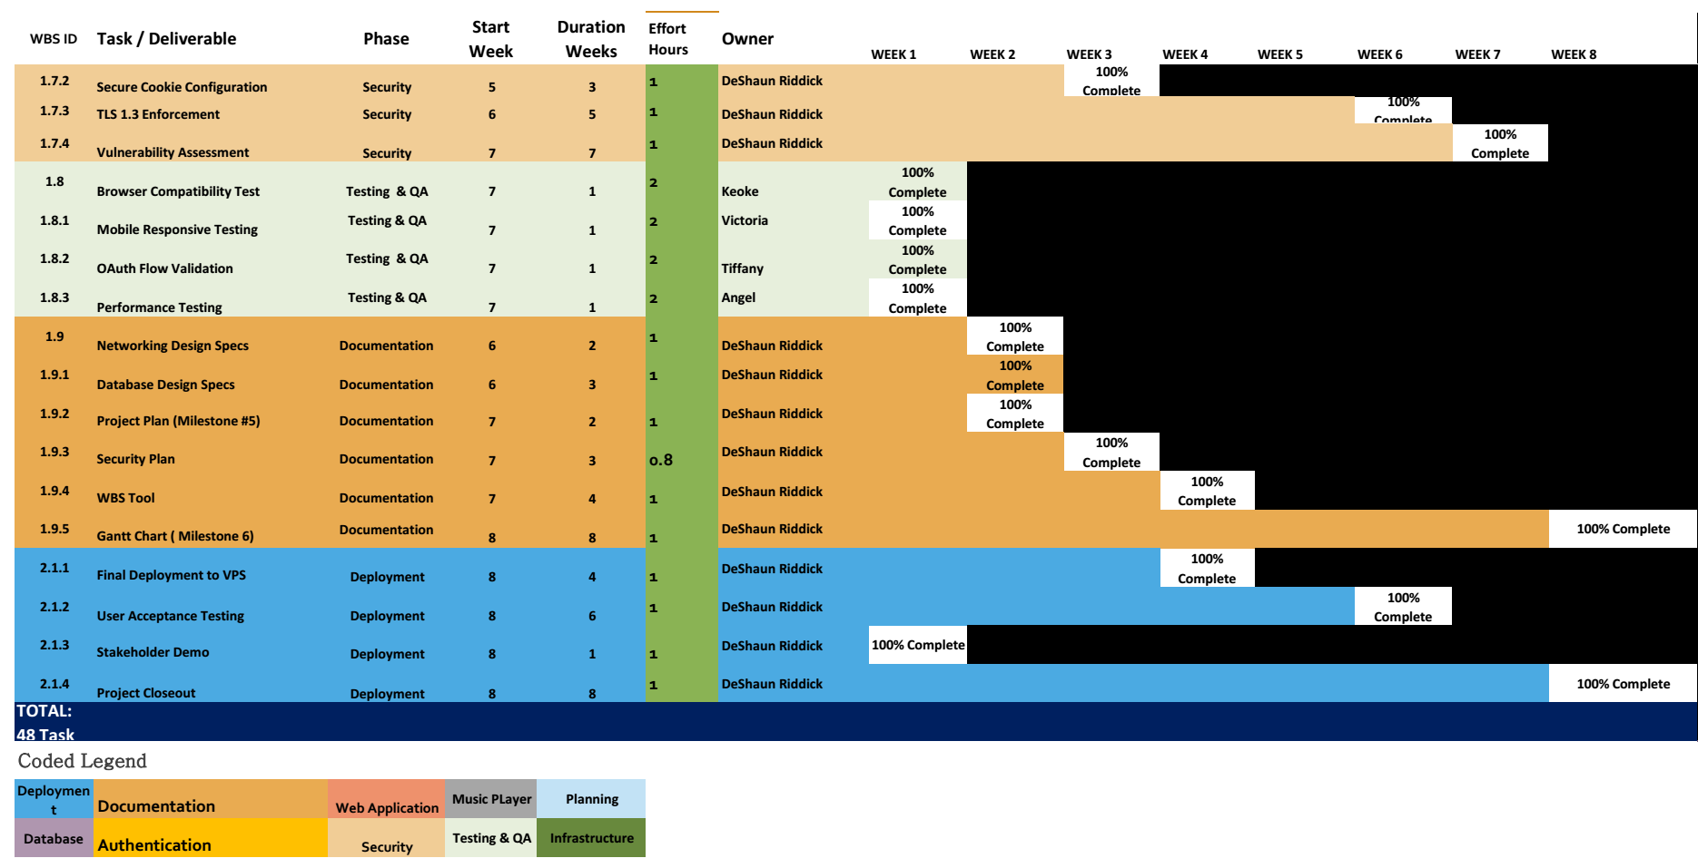

T-SAP ___Traffic Signal Access Portal Milestone 5: Project Plan & Security Plan

SECURITY PLAN
Click Link to Privacy Policy:
Last Updated: Friday, April 10, 2026
This Privacy Policy describes how T-SAP DeShaun Riddick ("we," "us," or "our") collects, uses, and shares information when you use our T-SAP application (the "App").
1. Information We Collect
We collect information to provide and improve our App for you. The types of information we collect depend on how you use our App.
- Information You Provide to Us:
  - Account Information: When you create an account, we may collect your name, email address, and Communications: When you communicate with us through user support email we collect the content of your communications and any contact information you provide.
- Information Collected Automatically when using Google Sign-In or other Google API Services:
  - When you log in using your Google account, we access your basic profile information name, email address, profile picture as permitted by your Google account settings and your consent.
- We use this information solely for Username and email address is collection for crash reporting and security.

  - We do not use your Google user data for advertising, and we do not sell your Google user data to third parties.
- Username and email address is collected for crash reporting and security.
2. How We Use Your Information
We use the information we collect for various purposes, including:
- To provide, operate, and maintain our App.
- To improve, personalize, and expand our App.
- To understand and analyze how you use our App.
- To develop new products, services, features, and functionality.
- To communicate with you, either directly or through one of our partners, including for customer service, to provide you with updates and other information relating to the App, and for marketing and promotional purposes.
- To process your transactions and manage your orders.
- To find and prevent fraud.
- To ensure the security and integrity of our App.
3. How We Share Your Information
We may share the information we collect in various circumstances, including:
- With Your Consent: We may share your information when you give us your explicit consent to do so.
- With Service Providers: We may share your information with third-party vendors, service providers, contractors, or agents who perform services for us or on our behalf and require access to such information to do that work. Examples include payment processing, data analysis, email delivery, hosting services, customer service, and marketing efforts.
- For Legal Reasons: We may disclose your information if required to do so by law or in response to valid requests by public authorities (e.g., a court or government agency).
- To Protect Our Rights: We may disclose your information where we believe it is necessary to investigate, prevent, or take action regarding potential violations of our policies, suspected fraud, situations involving potential threats to the safety of any person, and illegal activities, or as evidence in litigation in which we are involved.
- Business Transfers: We may share or transfer your information in connection with, or during negotiations of, any merger, sale of company assets, financing, or acquisition of all or a portion of our business to another company.
We will not sell your personal data to third parties.
4. Your Choices and Rights
You may have certain rights regarding your personal information, depending on your location and applicable laws. These may include the right to:
- Access the personal information we hold about you.
- Request correction of inaccurate personal information.
- Request deletion of your personal information.
- Object to our processing of your personal information.
- Request restriction of processing your personal information.
- Request data portability.
To exercise any of these rights, please contact us at d.sequence2@gmail.com.
5. Data Retention
We retain your personal information only for as long as necessary to fulfill the purposes for which it was collected, including for the purposes of satisfying any legal, accounting, or reporting requirements.
6. Security of Your Information
We use administrative, technical, and physical security measures to help protect your personal information. While we have taken reasonable steps to secure the personal information you provide to us, please be aware that despite our efforts, no security measures are perfect or impenetrable, and no method of data transmission can be guaranteed against any interception or other type of misuse.
7. Links to Other Websites
Our App may contain links to third-party websites that are not operated by us. If you click on a third-party link, you will be directed to that third party's site. We strongly advise you to review the Privacy Policy of every site you visit. We have no control over and assume no responsibility for the content, privacy policies, or practices of any third-party sites or services.
8. Children's Privacy
Our App is not intended for use by children under the age of [e.g., 13]. We do not knowingly collect personally identifiable information from children under [e.g., 13]. If you become aware that we have collected personal data from a child without parental consent, please contact us, and we will take steps to remove that information from our servers.
9. Changes to This Privacy Policy
We may update our Privacy Policy from time to time. We will notify you of any changes by posting the new Privacy Policy on this page and updating the "Last Updated" date. You are advised to review this Privacy Policy periodically for any changes. Changes to this Privacy Policy are effective when they are posted on this page.
10. Contact Us
If you have any questions or concerns about this Privacy Policy, please contact us:
- By email: d.sequence2@gmail.com

Purpose (Policy Statement)
Click Link: Terms of Service for Traffic Signal Simulator
Effective Date Friday, April 10, 2026Welcome to Traffic Signal Simulator (the "Service"), operated by T-SAP ("we," "us," or "our"). These Terms of Service ("Terms") govern your use of our website located at https://trafficsignalsim.com/ (the "Site") and any related services, features, content, and applications we offer (collectively, the "Service").
By accessing or using the Service, you agree to be bound by these Terms. If you disagree with any part of the Terms, then you may not access the Service.
1. Acceptance of Terms
By using our Service, you confirm that you have read, understood, and agree to be bound by these Terms, including any future modifications. If you are using the Service on behalf of an organization, you are agreeing to these Terms for that organization and representing that you have the authority to bind that organization to these Terms. 2. Description of Service
Traffic Signal Simulator is a Traffic Signal Simulator Access Portal (T-SAP). This document serves as a physical blueprint for the development team to build the system securely. It details the authentication protocols (OAuth), dashboard functionalities, any later mechanics, and security protocols required to replace the legacy plain text password database system. The Service is provided for viewing traffic phases for educational, research, and demonstration purposes.
3. User Accounts
- Account Creation: To access certain features of the Service, you may be required to create an account. You agree to provide accurate, current, and complete information during the registration process and to update such information to keep it accurate, current, and complete.
- Account Security: You are responsible for safeguarding the password that you use to access the Service and for any activities or actions under your password. You agree not to disclose your password to any third party. You must notify us immediately upon becoming aware of any breach of security or unauthorized use of your account.
- Age Restriction: You must be at least 13 or 18 years old to create an account and use the Service. By using the Service, you represent and warrant that you meet this age requirement.
4. User Conduct and Responsibilities
You agree not to use the Service for any purpose that is prohibited by these Terms or by applicable law. You are solely responsible for all your activities in connection with the Service. Prohibited activities include, but are not limited to:
- Violating any local, state, national, or international law or regulation.
- Infringing upon or violating our intellectual property rights or the intellectual property rights of others.
- Harassing, abusing, insulting, harming, defaming, slandering, disparaging, intimidating, or discriminating based on gender, sexual orientation, religion, ethnicity, race, age, national origin, or disability.
- Uploading or transmitting viruses or any other type of malicious code.
- Attempting to interfere with, compromise the system integrity or security, or decipher any transmissions to or from the servers running the Service.
- Collecting or harvesting any personally identifiable information, including account names, from the Service.
5. Intellectual Property
- Our Content: All content, features, and functionality on the Site, including but not limited to text, graphics, logos, icons, images, and the compilation thereof, and any software used on the Site, are our property or the property of our licensors and are protected by copyright and other intellectual property laws.
- Your Content: By submitting, posting, or displaying content on or through the Service, you grant us a worldwide, non-exclusive, royalty-free license (with the right to sublicense) to use, copy, reproduce, process, adapt, modify, publish, transmit, display, and distribute such content in any and all media or distribution methods. You retain any and all of your rights to any content you submit, post, or display on or through the Service and you are responsible for protecting those rights.
6. Termination
We may terminate or suspend your account and bar access to the Service immediately, without prior notice or liability, under our sole discretion, for any reason whatsoever, including without limitation a breach of the Terms. If you wish to terminate your account, you may simply discontinue using the Service. All provisions of the Terms which by their nature should survive termination shall survive termination, including, without limitation, ownership provisions, warranty disclaimers, indemnity, and limitations of liability.
7. Links to Other Websites
Our Service may contain links to third-party websites or services that are not owned or controlled by us. We have no control over, and assume no responsibility for the content, privacy policies, or practices of any third-party websites or services. We do not guarantee the offerings of any of these entities/individuals or their websites. You acknowledge and agree that we shall not be responsible or liable, directly or indirectly, for any damage or loss caused or alleged to be caused by or in connection with the use of or reliance on any such content, goods or services available on or through any such third-party websites or services. We strongly advise you to read the terms and conditions and privacy policies of any third-party websites or services that you visit.
8. Disclaimer of Warranties; Limitation of Liability
- Disclaimer: Your use of the Service is at your sole risk. The Service is provided on an "AS IS" and "AS AVAILABLE" basis. The Service is provided without warranties of any kind, whether express or implied, including, but not limited to, implied warranties of merchantability, fitness for a particular purpose, non-infringement or course of performance.
- Limitation of Liability: In no event shall T-SAP DeShaun Riddick nor its directors, employees, partners, agents, suppliers, or affiliates, be liable for any indirect, incidental, special, consequential or punitive damages, including without limitation, loss of profits, data, use, goodwill, or other intangible losses, resulting from (i) your access to or use of or inability to access or use the Service; (ii) any conduct or content of any third party on the Service; (iii) any content obtained from the Service; and (iv) unauthorized access, use or alteration of your transmissions or content, whether based on warranty, contract, tort (including negligence) or any other legal theory, whether or not we have been informed of the possibility of such damage, and even if a remedy set forth herein is found to have failed of its essential purpose.
9. Indemnification
You agree to defend, indemnify and hold harmless T-SAP DeShaun Riddick and its licensee and licensors, and their employees, contractors, agents, officers and directors, from and against any and all claims, damages, obligations, losses, liabilities, costs or debt, and expenses (including but not limited to attorney's fees), resulting from or arising out of (a) your use and access of the Service, by you or any person using your account and password; or (b) a breach of these Terms.
10. Governing Law
These Terms shall be governed and construed in accordance with the laws of New York, USA, without regard to its conflict of law provisions. Our failure to enforce any right or provision of these Terms will not be considered a waiver of those rights. If any provision of these Terms is held to be invalid or unenforceable by a court, the remaining provisions of these Terms will remain in effect.
11. Changes to Terms
We reserve the right, at our sole discretion, to modify or replace these Terms at any time. If a revision is material, we will provide at least 30 days’ notice prior to any new terms taking effect. What constitutes a material change will be determined at our sole discretion. By continuing to access or use our Service after any revisions become effective, you agree to be bound by the revised terms. If you do not agree to the new terms, you are no longer authorized to use the Service.
12. Contact Us
If you have any questions about these Terms, please contact us:

Risk Assessment
A risk assessment was conducted to identify potential threats to the T-SAP platform, evaluate their likelihood and impact, and determine appropriate mitigating controls.
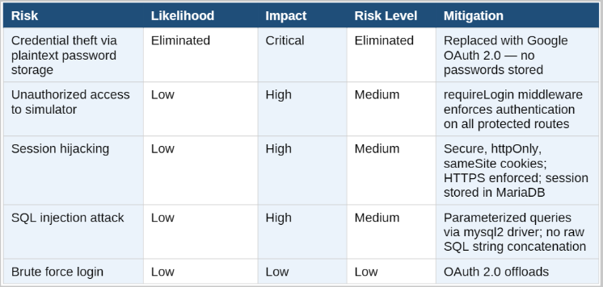
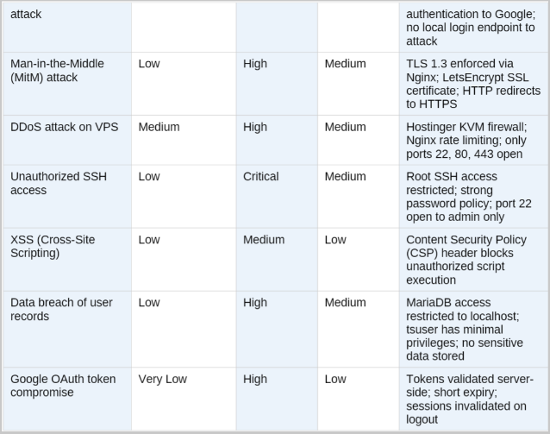

Control Activities

9.1 Firewall Configuration
A host-based firewall creates a boundary just before the host it is installed upon and adds another set of firewall policies to the architecture of the network. (Scarfone et al., 2009).
The T-SAP VPS is protected by a host-based firewall configured to allow only the minimum necessary network traffic:
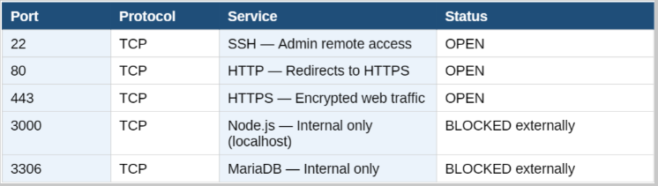

9.2 Intrusion Prevention & Detection
T-SAP implements the following intrusion prevention and detection measures:

Intrusion Prevention System (IPS) Controls:
- Nginx content security policy (CSP) header prevents unauthorized script- injection and cross site scripting attacks
- Nginx enforces TLS 1.3 minimum, blocking deprecated SSL/TLS protocol attacks
- HTTP Strict Transport Security (HSTS) prevents protocol downgrade attacks
- OAuth 2.0 eliminates brute force attacks surface by removing local login endpoints
- express- session with secure cookies prevents session fixation attacks
- sameSite cookie policy prevents Cross-Site Request Forgery (CSRF) attacks

Intrusion Detection System (IDS) Controls:
- PM2 log monitoring captures all application errors and unexpected behaviors
- MariaDB user_logins table records every authentication event with IP address and timestamp, enabling anomaly detection
- Admin dashboard provides real time visibility into login activity across all users
- Nginx Access logs capture all HTTP requests including failed authentication attempts
- Server uptime and process monitoring via PM2 detects unexpected process terminations

9.3 Access Controls
- All protected routes enforce authentication via requireLogin middleware
- Database access is restricted to Tsuser account with minimal privileges
- Environment variables (.env file) protect sensitive credentials from exposure
- Google OAuth scope limited to profile and Gmail- no access to other Google services
- Admin functions are accessible only to authenticate sessions

Organization of Information Security
The T SAP platform is developed and maintained by a single administrator who holds all security responsibilities. As the platform scales to support 10 field technicians from the New York State Department of Movement, the following organizational security structure is defined:
Role | Person/Entity | Security Responsibilities
System Owner | DeShaun Riddick | Accountable for overall security posture, policy enforcement, and compliance
System Administrator | Deshawn Riddick | VPS management, firewall rules SSL certificate renewal, systems update
Security Officer | Deshawn sequence2 | Security plan maintenance, risk assessment, incident response coordination
Database Administrator | DeSean sequence 2 | Database access control, user management, backup and recovery
Identity Provider | Google LLC | Authentication, identity verification, OAuth token issuance and validation
Field Technicians ( 10 ) | NYSDOM Personnel | Responsible for protecting their Google account credentials and reporting suspicious activity

Accountability of Assets
The following table defines the critical assets of the T-SAT platform and assigns accountability for their protection:
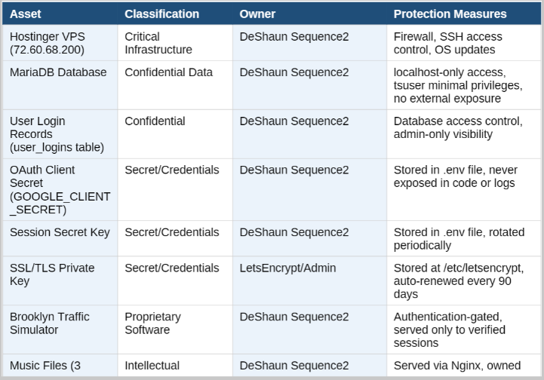
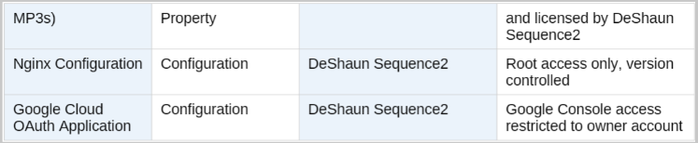

Communications

12.1 Security Communication Channels
The following communication protocols are established for T-SAP security events:
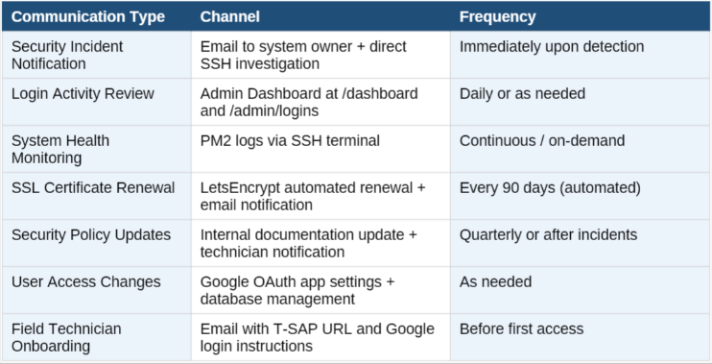

12.2 User Communication Policies
- All field technicians must be notified in writing before their Google account is authorized for T-SAP access
- Users must be informed of the privacy policy at https://trafficsignalsim.com/privacy before first login
- Without one, your app simply won’t be published (Team, 2026).
- Any changes to data collection practices must be communicated to users via updated privacy policy
- Security incidents affecting users’ data must be disclosed to affected users within 72 hours of discovery
- System maintenance windows must be communicated to field technicians at least 24 hours in advance

13. Incident Response Team
The T-SAP Incident Response Team (IRT) is responsible for detecting, analyzing, containing, and recovering from security events. Incident Response Team includes a team leader, incident handlers, forensic analysts, communication specialists, and legal advisors (Lancaster, 2025). Given the current scale of the T-SAP deployment, the IRT consists of the following roles:
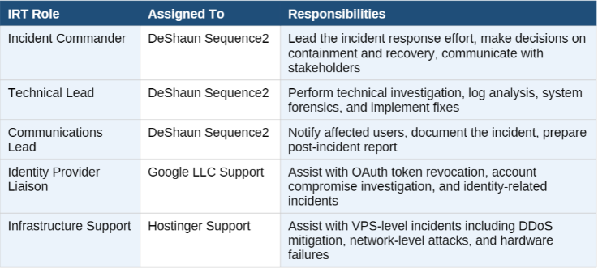

13.1 Incident Classification
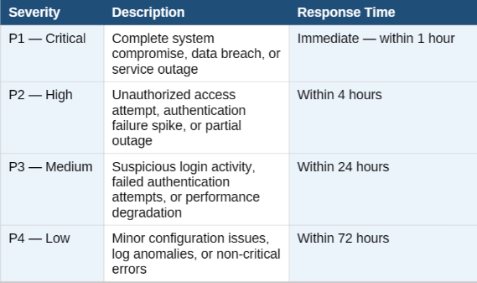

T-SAP ___Traffic Signal Access Portal Milestone 5: Project Plan & Security Plan

14. Incident Response Process
The T-SAP Incident Response Process follows the NIST SP-800-61 framework (Ccw, 2026), consisting of four phases: Preparation, Detection & Analysis, Containment/ Eradication/Recovery, & Post-Incident Activity or lessons learned.

Phase 1: Preparation
- Maintain current firewall rules blocking all non-essential ports
- Ensure PM2 logging is active and logs are reviewed regularly
- Keep Node.js, Nginx, and MariaDB updated with security patches
- Maintain current backups for server.js, Nginx configuration, and database schema
- Ensure SSH access credentials are stored securely and not shared
- Document all system configurations and maintain an asset inventory

Phase 2: Detection & Analysis
- Monitor PM2 logs for application errors and unexpected behaviors:
pm2 logs trafficsignalsim
- Review MariaDB user_logins at /var/log/Nginx/access.log for suspicious request patterns
- Validate SSL certificate status and expiry via LetsEncrypt
- Classify the incident severity using the P1-P4 classification system

Phase 3: Containment, Eradication, & Recovery

Immediate Containment:
- If active breach detected: immediately restart Node.js To terminate all active sessions: PM2 restart trafficsignalsim
- Clear all active sessions from MariaDB: DELETE FROM sessions;
- If unauthorized SSH access suspected: change root password immediately
- If OAuth credentials compromised: revoke and regenerate Google OAuth client secret via Google Cloud Console
- Block suspicious IP addresses at the firewall level if DDoS or brute force detected

Eradication:
- Identify and remove any malicious code or unauthorized files from the VPS
- Rotate all secrets: sessions secret, OAuth client secret, database password
- Update .env file with new credentials and restart application
- Review and harden Nginx and firewall configurations

Recovery:
- Restore services from last known good backup if necessary
- Verify all authentication flows functions correctly after remediation
- Re-enable access for authorized field technicians after confirming system integrity
- Monitor system closely for 48 hours post-recovery for signs of re-compromise

Phase 4: Post-Incident Activity
- Document the incident timeline, root cause, impact, and remediation steps
- Conduct a lessons-learned review to identify gaps and controls or processes
- Update the Security Plan to address identified weaknesses
- Notify affected users if their data was exposed, in compliance with applicable regulations
- Submit a post-incident report to course instructor if incident occurs during academic project
- Implement additional preventive controls based on lessons learned

References
830-1998 - IEEE recommended practice for software Requirements Specifications. (1998, October 20). IEEE Standard | IEEE Xplore. https://ieeexplore.ieee.org/document/720574/references#references

Ccw. (2026, February 28). NIST SP 800-61 Rev. 3 Incident Response Recommendations and Considerations for Cybersecurity Risk Management: A CSF 2.0 Community Profile. Cyber Compliance Watch. https://cybercompliancewatch.org/nist-sp-800-61/

Chadha, R. S., Singh, S., Singh, J., CDAC-Noida, Uttar Pradesh, India, & Shiv Nadar Institute of Eminence. (2024). An In-Depth Analysis of OAUth: a Secure Authorization Framework. International Journal for Research Trends and Innovation, 9(1), 806–807. https://ijrti.org/papers/IJRTI2401121.pdf

Erhabor, D. (2026, April 6). How to Authenticate Users in Kubernetes: x509 Certificates, OIDC, and Cloud Identity. freeCodeCamp.org. https://www.freecodecamp.org/news/how-to-authenticate-users-in-kubernetes-x509-certificates-oidc-and-cloud-identity/

Garn, B., Lang, D. S., Leithner, M., Kuhn, D. R., Kacker, R., & Simos, D. E. (2021). Combinatorially XSSing web application firewalls. 2021 IEEE International Conference on Software Testing, Verification and Validation Workshops (ICSTW), 85–94. https://doi.org/10.1109/icstw52544.2021.00026

Kendall, K. E., & Kendall, J. E. (2013). Systems analysis and design.
Kirvan, P., & Bigelow, S. J. (2021, November 4). single point of failure (SPOF). Search Data Center. https://www.techtarget.com/searchdatacenter/definition/Single-point-of-failure-SPOF

Lancaster, E. (2025, April 12). Incident Response Team structure: Roles and responsibilities - security-project.org. WordPress. https://security-project.org/incident-response-team-structure-roles-and-responsibilities/

Mueller, N. M. (n.d.). Credential stuffing | OWASP Foundation. https://owasp.org/www-community/attacks/Credential_stuffing

Open for public comment | Developing Security, Privacy, and Cybersecurity Supply Chain Risk Management Plans for systems. (2025, June 4). NIST. https://www.nist.gov/news-events/news/2025/06/open-public-comment-developing-security-privacy-and-cybersecurity-supply

Scarfone, K., Hoffman, P., National Institute of Standards and Technology, & Virtual Private Network Consortium. (2009). Guidelines on firewalls and firewall policy. In NIST Special Publication 800-41 (p. 48) [Report]. National Institute of Standards and Technology. https://nvlpubs.nist.gov/nistpubs/legacy/sp/nistspecialpublication800-41r1.pdf

Solutions, S.-. E. S. &. I. (2025, June 11). SAML SSO: 8 Easy Steps to understand how it works (2025 Guide). SSOJet - Enterprise SSO & Identity Solutions. https://ssojet.com/blog/saml-sso-how-it-works-guide#saml-sso-how-it-works-in-8-simple-steps-2025

SSL Corp. (2025, May 5). What is HTTPS? - SSL.com. SSL.com. https://www.ssl.com/faqs/what-is-https/

Team, L. (2026, April 16). What is a privacy policy? Definition and legal requirements - LegalClarity. LegalClarity. https://legalclarity.org/what-is-a-privacy-policy-definition-and-legal-requirements/

Vastel, A. (2025, June 25). Credential stuffing attacks: anatomy, detection, and defense - Security Boulevard. Security Boulevard. https://securityboulevard.com/2025/06/credential-stuffing-attacks-anatomy-detection-and-defense/

